
PAYYAP, LLC

Shea Writer, Founder & CEO

https://payyap.network

(p): 917.310.0864 (e): shea.writer@payyap.network
Management Team:
Shea Writer, Founder & CEO
M. Shahid Ulla, Senior Software Engineer
Peter Malliaras, Senior Customer Support

Industry:
Global Mobile Payments

Financing-to-date:
$373,500 invested by Founders to design and develop the software and bring it to market.

Financing Sought:
$500,000 for 20.00% Equity

Use of Funds:
The funds will be used to expand marketing and advertising efforts, hire technical and customer support personnel, and for working capital needs.
Business Description
PAYYAP is revolutionizing consumer payments with biometrically secured, voice-driven AMEX, VISA, MasterCard & Discover payments in real-time via “6th Channel” technology!

Pilot Metrics
The initial pilot program that PAYYAP rolled out internationally resulted in 1,000+ registered vendors (downloads), 200+ verified IDs, and $200,000 total payment volume. After partnering with TSYS/ProPay (top 10 merchant bank in North America), we paused the International Pilot to focus specifically on penetrating the US market. User metrics from our pilot programs are shown below:
Int’l Metrics (paused)
USA Metrics (LIVE)
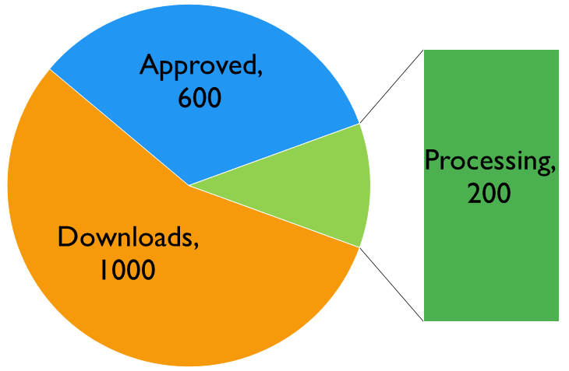
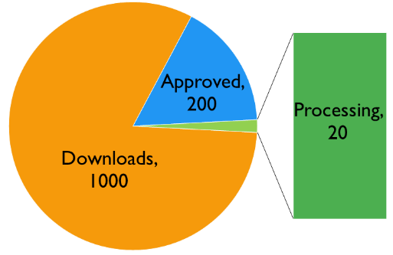

Business Opportunity
Mobile devices are increasingly used for payment processing, but current solutions still require the use of supplementary hardware before being able to take payments. To make the process easier, PAYYAP has created a revolutionary payment app that offers faster payments and safer e-commerce without the use of Squares, dongles, or hardware plugins of any kind. PAYYAP has solved the adoption and security issues that have (until now) prevented real-time bank card transaction processing via telephone. As a result of solving these issues, PAYYAP is first-to-market with merchant-initiated, interactive voice response payment processing – a “6th distribution channel” for bank card transactions.

How it Works:
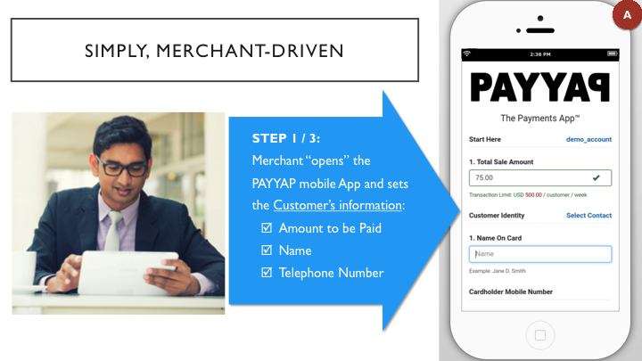
- And then:
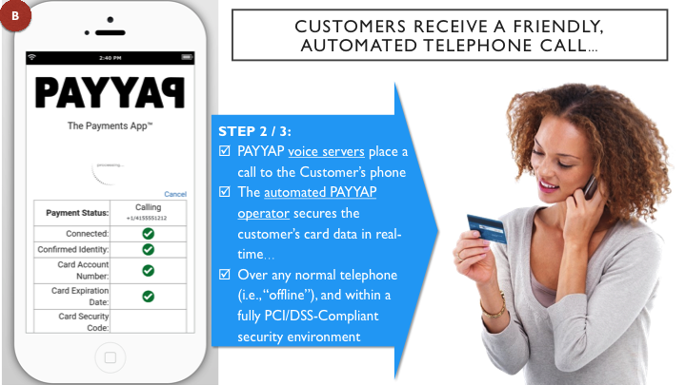

- And finally:
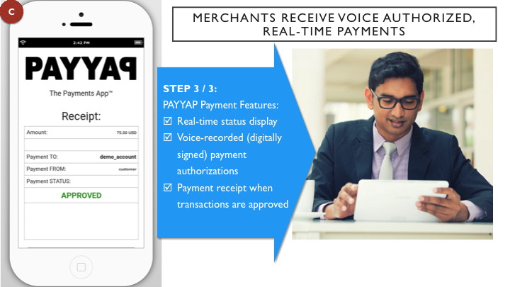

- PAYYAP breaks the “Payments Catch-22” by appealing specifically and intently to a fresh, high-demand niche of SMB’s that are looking for a “100% APP-based” -- i.e., no additional squares, “swipers” or scanners) billing solution – a “6th payment channel”:
  - 100% “built-in” PCI-DSS security compliance;
  - Zero security obligations for the SMB (cuts account application time);
  - Immediately intuitive for customers to receive a simple, automated telephone call;
  - Simply attractive merchant interface displays real-time transaction status updates.

Competitive Analysis
 | Pricing | Markets | “Payer” Considerations | Advantage
PayPal | 3.1% + $0.30  (+ $30.00 / month) | Global | Must have access to the internet access | Economy of scale; Ability to quickly buy innovators
PAYYAP | 2.60% - 3.35%  (+ $1 bank deposit fee) | Global | Any telephone | Easiest way to get paid over telephone; First mover advantage
Square | 2.75% - 3.75% | AU, JP, US, UK | Regionally limited; Must have access to the internet | It was a first mover in the mobile “card swipe” market
venmo | 3.0% | US | Must have venmo App; Regionally limited | Free bank to bank transfers
Western Union | 5% - 50% | Global | Time consuming; Expensive | Cash-In / Cash-Out

Value Proposition
The easiest way to get paid – VIA “APP”
Value to Businesses | Value to Customers
- The absolute easiest way to get paid via APP.  - Recorded voice authorizations (per payment) reduce fraud and disputes  - Real-time payment completion  - Auto-payment receipt (email or SMS when available)  - Globally viable, and quickly | - No desktop / laptop / tablet required  - No internet required / no Apps to download  - Receiving an automated telephone call is familiar & free  - Quickly complete payments by speaking to an automated operator (or using the telephone keypad)  - Voice biometric security enables fast repeat use

Go-to-Market Strategy
Phase 1 - Completed
Before a payment processing company can begin offering services, it must partner with a merchant bank so that it can handle customer transaction. There are three types of merchant banks: International (extremely conservative lending practices), US Domestic (Conservative lending practices), and Off-shore / grey area (least conservative lending practices). PAYYAP’s initial market launch was done through an off-shore bank because the Company did not have the necessary collateral or existing track record to partner with a more conservative bank. Even with interest rates between 7.9% - 9.9%, and terrible transaction approval rates, PAYYAP was still able to process a total payment volume of $200,000 from international vendors during its pilot program.

Once PAYYAP began generating revenue and creating a customer base, we were able to partner with TSYS, a U.S. merchant bank. Upon entering into an agreement with TSYS, PAYYAP paused its international pilot program to focus on the U.S. market. Even though we plan on staying in the U.S. market, the real value in our business model comes from the international market where vendors or largely underserved and have limited to no access to payment processors!

Phase 2 - Next Step
After securing investment funds, PAYYAP will immediately begin developing PAYYAP - The Payments App™ in a second language, either Spanish or Chinese. This will speed up our international adoption rates as we will offer vendors their choice of language to use. In order to penetrate international markets with competitive rates, we will partner with an international bank so that our interest rates on international transactions will be around 4% instead of 7.9% - 9.9%. PAYYAP will focus on penetrating the international markets because of the overwhelming lack of competition. This was evidenced during our pilot programs which showed that the international marketplace will be at least 10x more lucrative than the U.S. market.

Distribution Channels
Business-to-Consumer (B2C): PAYYAP – The Payments App™ is available for free – as a mobile & tablet APP – and is available for download via Google Play Store, Apple App Store, or Amazon App Store.
Business-to-Business (B2B): PAYYAP LLC has also developed a “white label” plugin that will appeal to the global banking industry and payment gateways worldwide looking to add pure-APP, “6th channel payments” to their own, local menu of payment offerings (i.e., along w/ current standards like “email invoicing”, “online shopping carts”, etc.).

Use of Funds
$500,000  Current Round |  | $3,000,000  Next Round
Primary purpose is to bring on technical staff to complete back-end preparation to launch into international markets (Spanish or Chinese)  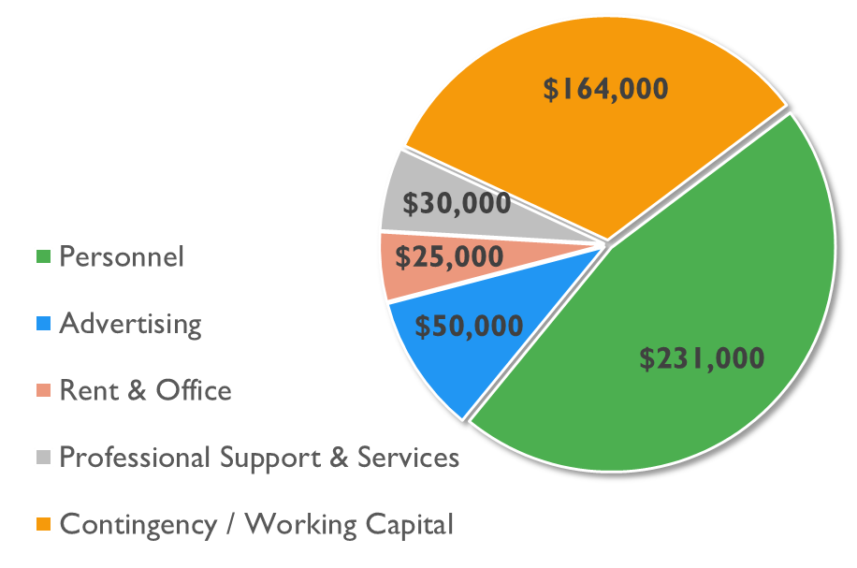 |  | 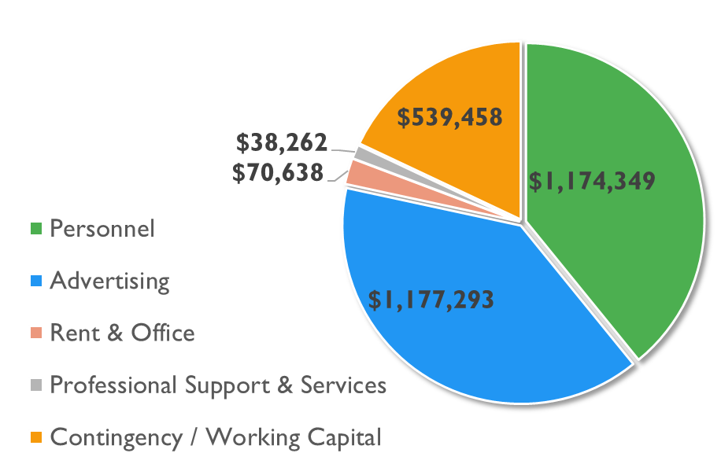  Primary purpose is to bring on more technical & support staff and to aggressively ramp-up marketing & advertising efforts domestically and abroad.

Financial Summary & Investor ROI

 | Year 1 | Year 2 | Year 3
NET REVENUE | $ 140,468 | $ 6,105,983 | $ 26,234,168
Operating Expenses | 1,701,665 | 5,103,360 | 5,013,360
EBIT | $ (1,561,197) | $ 1,002,623 | $ 21,130,808
Investment Amount | $ 500,000
Investor's Equity Position | 20.00% | 14.00% | 14.00%
EBIT Acquisition Multiple | 10.0 | 10.0 | 10.0
Market Value of PayYap | $ 2,500,000 | $ 10,026,231 | $ 211,308,081
Investor’s Market Value | $ 500,000 | $ 1,403,672 | $ 29,583,131
 | Investor ROI (year 3 exit) |  | 58X

